

**SURANA COLLEGE-Autonomous**

Affiliated to Bangalore University

Recognized under 2(f) and 12 B of UGC, Certified by ISO, Re-accredited by NAAC with A+

No 16, South End Road, Bengaluru-560 004

# **INTERNSHIP REPORT**

**PYTHON AND DATA ANALYTICS INTERNSHIP - STUDENT PERFORMANCE ANALYSIS**

**Submitted to**

**SURANA COLLEGE-Autonomous**

In partial fulfilment for the curriculum requirement for

# **BACHELOR OF COMPUTER APPLICATIONS**

**By**

**S DHARSHAN**

**U03ME23S0041**

**Under the Guidance of**

**ASHA H**

Assistant Professor, Dept of Computer Science SURANACOLLEGE-Autonomous, Bengaluru- 560 004

**2025-2026**

# **DECLARATION**

**S DHARSHAN AUGUST 2025**

**BCA**

I**, S DHARSHAN** hereby declare that the internship report, entitled **“PYTHON AND DATA ANALYTICS – STUDENTS PERFORMANCE ANALYSIS”** submitted to **SURANA COLLEGE-Autonomous, i**n partial fulfilment for the curriculum requirement for **BACHELOR OF COMPUTER APPLICATIONS done** by me during 2025-2026 under the guidance of **ASHA.H,** Assistant Professor, Department of Computer Science, SURANA COLLEGE-Autonomous, Bengaluru. It has not formed the basis for the award any Degree/Diploma/Associateship/Fellowship or other similar title to any candidate in any College/University.

**S DHARSHAN**

# **ACKNOWLEDGEMENT**

I am extremely delighted and grateful to thank every single person who helped me in completing my dissertation successfully. I thank the almighty for bestowing me with his blessings. I’m very much indebted and extend my deep sense of gratitude to **ASHA H,** Assistant Professor, Department of Computer Science, internship guide, for her consistent words of motivation, encouragement and filling me completely with insight regarding the topic throughout the period of my study. She was present whenever I needed her the most during the completion of my internship.

My sincere thanks are to the faculty members of Department of Computer Science, for their encouragement in my academic endeavors.

I thank my parents and Ms. **SHAMBHAVI,** External Guide**,** Dyashin technosoft pvt ltd for being very liberal towards me and for having complete trust in me during the course of my internship.

**S DHARSHAN**

| Sl. No. | Content | Page No |
| --- | --- | --- |
| 1 | **Chapter 1: Introduction** | 01 |
| 1.1 | Industry Overview | 01 |
| 2 | **Chapter 2: Organisation Profile** | 02-06 |
| 2.1 | History | 02-03 |
| 2.2 | About | 04 |
| 2.3 | Vision and Mission | 04 |
| 2.4 | Structure of the Organisation | 05-06 |
| 3 | **Chapter 3: Technology used** | 07-09 |
| 3.1 | Day/Week wise report | 07-08 |
| 3.2 | Application used | 09 |
| 4. | **Chapter 4: Conclusion** | 10-24 |
| 4.1 | Learning | 10 |
| 4.2 | Outcome | 11 |
| 4.3 | Snapshots of Project Work and Analysis | 12-22 |
| 4.4 | Summary of the Project | 23 |
| 4.5 | Recommendations to Improve Student Performance | 24 |

**TABLE CONTENTS**

**CHAPTER 1: INTRODUCTION**

**1.1 INDUSTRY OVERVIEW**

The data analytics industry is experiencing rapid expansion, driven by the exponential growth of digital data and the increasing demand for data-driven decision-making across sectors. As of 2024, the global market is valued at approximately USD 69.54 billion and is projected to reach USD 302.01 billion by 2030, with a compound annual growth rate (CAGR) of 28.7%. This surge is fuelled by advancements in artificial intelligence (AI), machine learning (ML), and cloud computing, which have made analytics tools more powerful, scalable, and accessible. Major players such as IBM, Microsoft, Oracle, SAP, AWS, and Tableau are leading the charge, offering sophisticated platforms that cater to diverse business needs. Key trends shaping the industry include predictive analytics for forecasting, real-time analytics for instant insights, and data democratization, which empowers non-technical users to interpret data through intuitive interfaces. Industries like healthcare, retail, finance, manufacturing, and human resources are leveraging analytics to improve efficiency, personalize services, and mitigate risks.

Despite its promising trajectory, the data analytics industry faces several challenges. Data privacy and security are critical concerns, especially with stringent regulations like GDPR and CCPA requiring responsible data handling. Organizations must invest in secure infrastructure and ethical practices to maintain trust and compliance. Another major hurdle is the shortage of skilled professionals, as demand for data scientists and analysts continues to outpace supply.

**2.ORGANIZATION PROFILE**

**2.1 HISTORY**

Dyashin Technosoft, while officially incorporated as a private limited company in India on September 12, 2023, has a deeper story rooted in the experience of its founding team. The company describes itself as being "led by a group of industry veterans," suggesting that its leaders brought significant knowledge and expertise to the new venture. The name "Dyashin" itself combines the concepts of "dynamic growth" and "shining excellence", reflecting the company's aspirations.

**The early stages:**

* September 12, 2023: Dyashin Technosoft was officially incorporated in India. Some sources also list September 11, 2023
* Initial focus: The company initially focused on providing custom software development, managed IT services, and other related services.
* Building a foundation: During its early years, Dyashin Technosoft likely concentrated on establishing credibility, building a client base, and developing its expertise in core competencies such as software development and enterprise integration.

**Key milestones and growth:**

* Early recognition: By 2012, Dyashin had secured its first international client, marking a turning point that propelled the company to develop a global delivery model and enhance its project management capabilities.
* Infrastructure expansion: In 2013, the company moved into its first fully owned office in Whitefield, Bangalore, signifying its transition from a startup to a more established organization.
* Service diversification: From 2015 to 2018, Dyashin Technosoft expanded its service offerings to include cloud computing, DevOps, mobile app development, enterprise integration services, and data warehousing.
* Global expansion: The company established offices in the United States and the United Kingdom, along with offshore support hubs in other countries, to strengthen its global presence.
* Brand consolidation: In 2020, the company undertook a brand identity revamp, launching a new visual identity, website, and corporate messaging focused on "Accelerating Digital Futures".

**Innovation and sustainability:**

* Dyashin Labs: The company launched Dyashin Labs, its dedicated innovation hub, to focus on emerging technologies like IoT, machine learning, and Robotic Process Automation (RPA).
* Proprietary platforms: Dyashin has invested in and launched its own platforms like DyashinView (a business intelligence tool), DyashinEdge (a cloud-native DevOps management platform), and DyasChain (a blockchain integration layer).
* Focus on CSR: Dyashin is committed to green IT practices, carbon footprint reduction, and corporate social responsibility (CSR) through its "Dyashin Cares" initiative.

**Present-day operations:**

* Global presence: Dyashin Technosoft operates globally with offices in the USA, India, UK, and UAE.
* Structured operations: The company's operations are organized into three key business units: the Digital Solutions Group (DSG), Enterprise Services Group (ESG), and Innovation & Products Group (IPG).
* Industry verticals: They serve diverse industries such as FinTech, healthcare, retail, logistics, and education.

In essence, Dyashin Technosoft's history is one of continuous growth, diversification, and a strong commitment to innovation and customer success. The company's focus on industry expertise, global expansion, and strategic partnerships has allowed it to establish itself as a recognized player in the software development and engineering services industry.

**2.2 ABOUT THE DYASHIN TECHNOSOFT**

Dyashin Technosoft is a renowned [Software Development](https://dyashin.com/solutions/software-development) and [Engineering services](https://dyashin.com/services) company led by a group of industry veterans. With our passion, knowledge, and commitment to excellence, we believe in transforming the arena of software development and empowering customer businesses to embrace the future and achieve amazing success. Our comprehensive range of custom software services & Solutions are designed to assist our customers at all stages of the SDLC, assuring project success from start to end and beyond.

**2.3 VISION AND MISSION**

**Vision**

To be a global standard company to provide Value Driven IT services, Innovative Engineering Solutions & Reliable NexGen products for a better tomorrow.

**Mission**

Fostering long lasting relationships and driving mutual growth with our customers, employees & vendor partners in the ever-evolving landscape of technology**.**

**2.4 STRUCTURE OF ORGANISATION**

Dyashin Technosoft is a privately held technology company in India, specializing in information technology and computer service activities. Founded and led by CEO Madan Shamachar, the organization operates with a well-defined hierarchical management structure that ensures smooth coordination across all functions. The leadership team includes key figures such as Swathi Rao, who serves as the Account Manager, overseeing client relationships and project delivery, and Sushma Malali, the Senior Business Analyst responsible for bridging business needs with technical solutions.

The company is organized into specialized departments—Sales, Operations, and Product & Engineering—each with its own leadership and dedicated teams. This clear departmental division allows for focused execution of responsibilities, from generating business opportunities to delivering high-quality technology solutions. The Product & Engineering wing is guided by Chief Technology Officer Praveen Dyamappa, who spearheads software development, product innovation, and engineering excellence.

Dyashin Technosoft primarily delivers software development and engineering services, positioning itself as a solutions-oriented partner for clients in various industries. Its expertise spans building robust software products, optimizing business processes, and offering tailored IT services.

From a legal standpoint, the company is registered as a Private Limited Company under Indian corporate law, which offers operational flexibility while ensuring compliance with regulations. Interestingly, Dyashin Technosoft is an unfunded enterprise, meaning it grows through internally generated resources rather than external investments. This approach reflects a self-sustaining business model, emphasizing steady, organic growth and operational independence, which in turn strengthens its long-term stability and credibility in the competitive IT sector.

**Services provided by dyashin technosoft company are:**

**1. Software Development:**

• Dyashin offers custom software development services tailored to various business needs.

• They provide support throughout the entire Software Development Life Cycle (SDLC) or Product Development Life Cycle (PDLC).

**2. Software QA & Testing:**

• Dyashin provides quality assurance and testing services to ensure software meets high standards.

• This includes various testing methods like manual, automation, performance, security, and API testing.

**3. Engineering Services:**

• Dyashin offers engineering services, including those related to semiconductor and embedded systems.

**4. Consulting Services:**

• Permanent Hire: They assist with permanent placements, finding the right talent for specific roles.

• Contract Staffing: They provide dedicated account managers for sourcing talent for contract positions.

• Contract-to-Hire Staffing: They offer a pathway for clients to transition contract employees to permanent roles.

• Build, Operate & Transfer (BOT): Dyashin helps clients build, operate, and then transfer teams to the client's payroll.

• Just in Time Hiring: They focus on providing resources as needed, ensuring timely support.

**5. Learning Services:**

• Corporate Learning Programs: They offer skill development initiatives for corporate clients.

• Campus Programs: They provide comprehensive tech-enabled learning experiences for students.

• Off-Campus Programs: They cater to the retail segment with technology-focused training.

**CHAPTER 3: TECHNOLOGY USED**

**3.1WEEKLY REPORT**

| **Date** | **Task Description** | **Time spent** | **Task Category** | **Status** |
| --- | --- | --- | --- | --- |
| 01-07-25 | Introduction, History and  Architecture of python. | 1 hour 30 minutes | Theory class | Completed |
| 02-07-25 | Creating project in  PyCharm,  In-built function and  Comment lines | 1 hour 30 minutes | Practical + Theory class | Completed |
| 03-07-25 | Variables, Data Type and Type casting. | 1 hour 30 minutes | Practical + Theory class | Completed |
| 04-07-25 | Operators,  Conditional statement | 1 hour 30 minutes | Practical + Theory class | Completed |
| 07-07-25 | Basic programs,  Control Statement | 1 hour 30 minutes | Practical + Theory class | Completed |
| 08-07-25 | Strings  String function | 1 hour 30 minutes | Practical +  Theory class | Completed |
| 09-07-25 | User define function,  Collections-list and  Tuple | 1 hour 30 minutes | Practical + Theory class | Completed |
| 10-07-25 | Set and dictionary,  Class and object | 1 hour 30 minutes | Practical + Theory class | Completed |
| 11-07-25 | Oops concept | 1 hour 30 minutes | Practical + Theory class | Completed |
| 14-07-25 | NumPy library in  python, Array | 1 hour 30 minutes | Practical + Theory class | Completed |

| 15-07-25 | Basic Function in  NumPy | 1 hour 30 minutes | Practical + Theory class | Completed |
| --- | --- | --- | --- | --- |
| 16-07-25 | Indexing and slicing  of array | 1 hour 30 minutes | Practical + Theory class | Completed |
| 17-07-25 | Arrays access, Import  image using array | 1 hour 30 minutes | Practical + Theory class | Completed |
| 21-07-25 | Pandas’ library Analysing data from datasets | 1 hour 30 minutes | Practical + Theory class | Completed |
| 22-07-25 | Merge, Concatenation of  Data | 1 hour 30 minutes | Practical + Theory class | Completed |
| 23-07-25 | Filtering data | 1 hour 30 minutes | Practical + Theory class | Completed |
| 24-07-25 | Visualization, EDA | 1 hour 30 minutes | Practical + Theory class | Completed |
| 25-07-25 | SQL Installation and  Basic | 1 hour 30 minutes | Practical + Theory class | Completed |
| 28-07-25 | Introduction to DBMS  Introduction to SQL | 1 hour 30 minutes | Theory class | Completed |
| 29-07-25 | DDL commands  DML commands  DQL commands | 1 hour 30 minutes | Practical + Theory class | Completed |
| 30-07-25 | Data types  Constraints  Primary keys | 1 hour 30 minutes | Practical + Theory class | Completed |
| 31-07-25 | Operators | 1 hour 30 minutes | Practical + Theory class | Completed |
| 01-08-25 | Joins  Functions | 1 hour 30 minutes | Practical + Theory class | Completed |

**3.2 APPLICATION USED**

**Visual Studio Code (VS Code)**

* Purpose: Executed Python scripts for data preprocessing, cleaning, and transformation.
* Why VS Code: It offers an efficient coding environment with features like IntelliSense, debugging tools, and seamless integration with Python extensions.
* Usage: I wrote and tested core Python functions, including data manipulation using libraries such as pandas, NumPy, and custom logic for handling missing values and formatting.

**Google Colab**

* Purpose: Performed exploratory data analysis (EDA) and visualizations.
* Why Google Colab: It provides a cloud-based, collaborative environment with access to GPU acceleration and pre-installed libraries, making it ideal for data analysis.
* Usage: I imported the dataset into Colab to generate visual insights using libraries like matplotlib and seaborn. Colab’s interactive cells allowed for iterative exploration and real-time adjustments to the analysis.

**SQL Compiler**

* Used to practice and execute SQL queries in a structured environment.
* Facilitated learning of key SQL concepts such as joins, constraints, functions, and primary keys.
* Enabled interaction with sample databases to simulate real-world relational data scenarios.

**CHAPTER 4: CONCLUSION**

**4.1 LEARNING**

During my internship, I developed a solid understanding of several essential tools and technologies for programming and data analysis. I began with the basics of Python, learning core concepts such as variables, data types, loops, conditional statements, and functions. I also explored Python’s built-in data structures like lists, tuples, dictionaries, and sets, which helped me write efficient and organized code.

Next, I learned Pandas, a powerful Python library for data manipulation and analysis. I practiced working with Data Frames and Series, importing datasets from various sources, cleaning data, handling missing values, sorting, filtering, grouping, and performing aggregations. This allowed me to transform raw data into a structured format suitable for analysis.

To visually represent data, I used Matplotlib, creating plots such as bar charts, line graphs, histograms, and scatter plots. I learned how to customize visuals with labels, legends, and colours, making the presentation of results clearer and more engaging.

In addition, I worked with Pillow, a Python imaging library, to process and manipulate images. I learned how to open, resize, crop, and save images in different formats, as well as apply filters and enhancements. This skill added versatility to my Python knowledge, especially for projects involving image-based data.

I also gained knowledge of SQL (Structured Query Language) for database management. I wrote queries to create, retrieve, update, and delete records, and used advanced operations like joins, grouping, and ordering to extract meaningful information from relational databases.

Finally, I applied these skills to dataset analysis, performing data cleaning, exploratory analysis, visualization, and interpretation of results. The internship enhanced my problem-solving abilities, improved my technical expertise, and gave me hands-on experience in applying programming, visualization, image processing, and database skills to real-world scenarios.

**4.2 OUTCOME**

As part of my internship, I worked on a Student Performance Analysis project using Python. The main objective of the project was to identify the key factors affecting students’ exam performance and provide insights to help improve their results. I used a student dataset containing information such as attendance, study hours, parental education level, extracurricular activities, internet usage, sleep patterns, and other demographic and academic details.

Using Pandas, I cleaned and organized the dataset, handled missing values, and grouped the data for meaningful comparisons. I applied Matplotlib to create visualizations like bar charts, histograms, and scatter plots, making it easier to identify patterns and relationships between different factors and exam scores. I analysed various aspects such as the impact of regular attendance, study habits, teacher quality, and motivation levels on student performance. The findings revealed that consistent attendance, adequate sleep, balanced extracurricular involvement, and strong teacher support significantly contribute to higher exam scores.

This project provided actionable insights that could help educators and institutions design better teaching strategies, improve student engagement, and create personalized learning plans, ultimately aiming to enhance overall academic performance.

* 1. **SNAPSHOTS OF PROJECT WORK AND ANALYSIS**
     1. **Gender Analysis**

**4.3.1.1 Distribution of Gender code for (pie chart). 4.3.1.2 Average Exam Score by Gender code for** 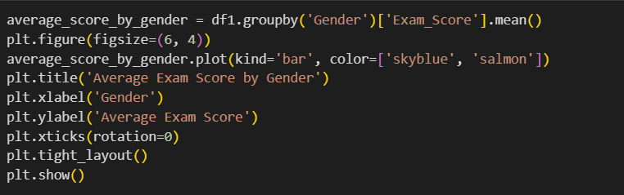

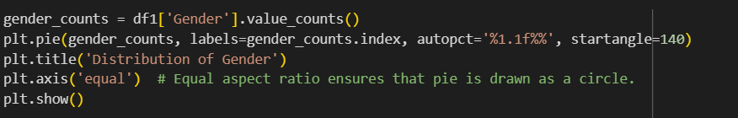 **(Bar graph)**

**4.3.1.1 Pie chart**  **4.3.1.2 Bar graph**

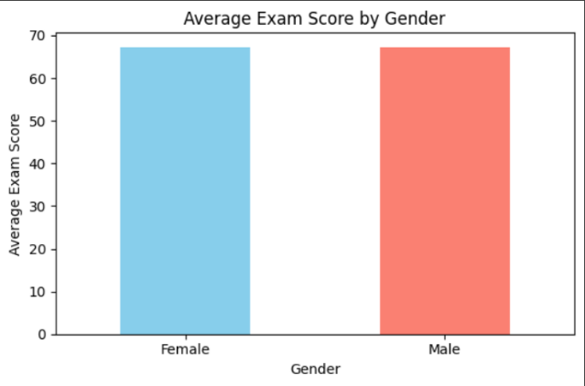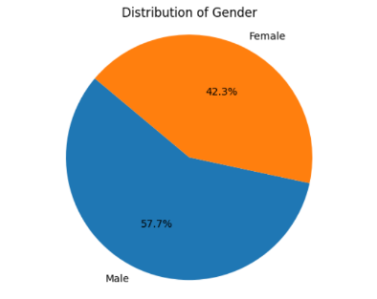

**4.3.1.2 Average Exam Score by Gender**

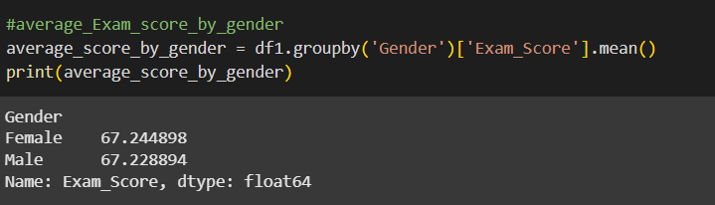

**Description:**

* The pie chart shows the proportion of Male and Female students in the dataset.
* This helps us understand whether the dataset is balanced or if one gender is more represented than the other.The bar chart display the average exam score for each gender.
* This would mean female students scored higher than male students on average.
* Even if female gender is less in number, their average score is higher, indicating better performance per student.

**4.3.2 School Type Analysis**

**4.3.2.1 Distribution of School Type code for (pie chart)**

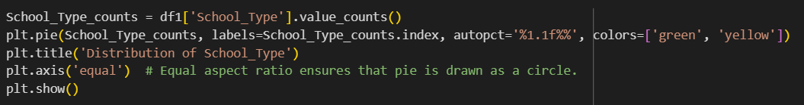

**4.3.2.1 Pie chart 4.3.2.1 Distribution of School Type**

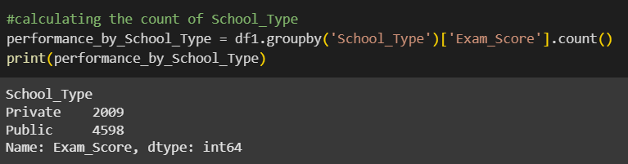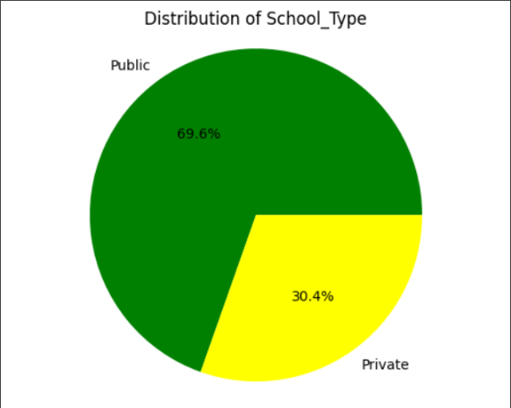

**4.3.2.2 Average Exam Score by Gender**

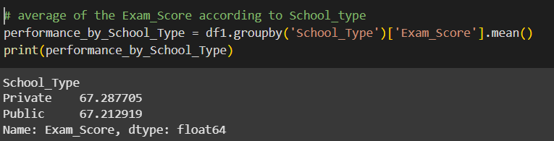

**Description:**

* In pie chart we can see the public school is high
* This could mean public schools has more number of students, or simply that more data was collected from them.
* Despite assumptions that private schools might perform better, the difference is just 0.08 points—statistically insignificant
* School type alone may not be a strong predictor of exam performance.

**4.3.3 Extracurricular Activities Analysis**

**4.3.3.1 Distribution of Extracurricular Activities( pie chart )**

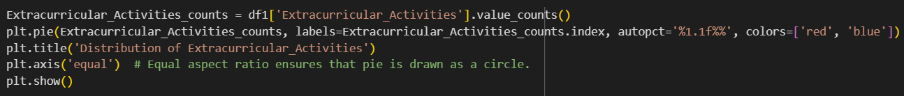

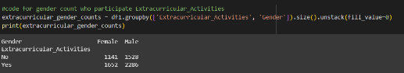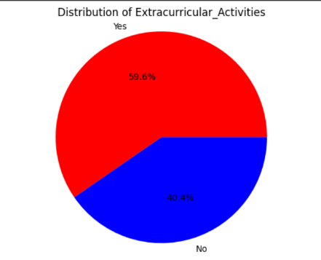 **4.3.3.1 Pie chart 4.3.3.2 Gender count who participate Extracurricular Activities**

**4.3.3.3 Average Exam Score by Extracurricular Activities for 4.3.3.3 Bar graph**

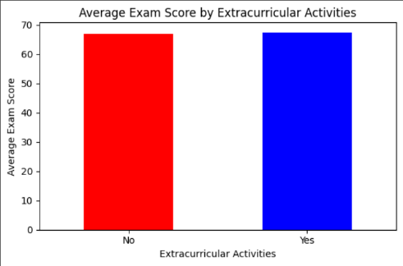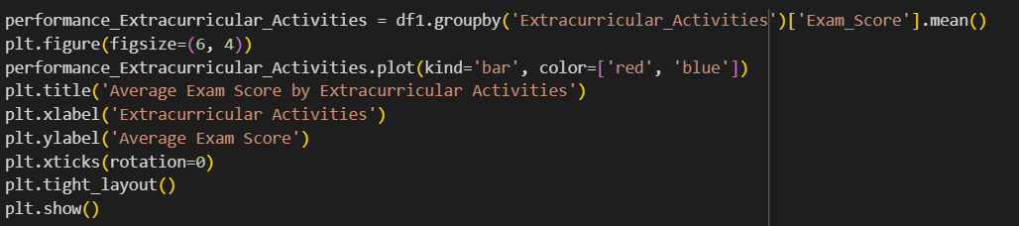 **(bar graph)**

**Description:**

* Nearly 60% of students are involved in extracurriculars.
* Males participate more than females, both in absolute numbers and proportionally.
* This data could be used to explore whether extracurricular involvement impacts academic outcomes, confidence, or social development
* Students involved in extracurriculars tend to perform slightly better academically.
* The difference is small but consistent, suggesting a positive correlation between extracurricular involvement and academic performance.

**4.3.4 Attendence Anaylsis**

**4.3.4.1 Correlation between Exam Score and Attendance Code for (scatter plot)**

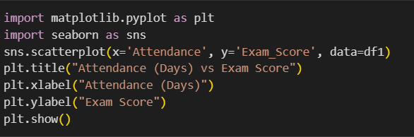

**4.3.4.1 Scatter plot**

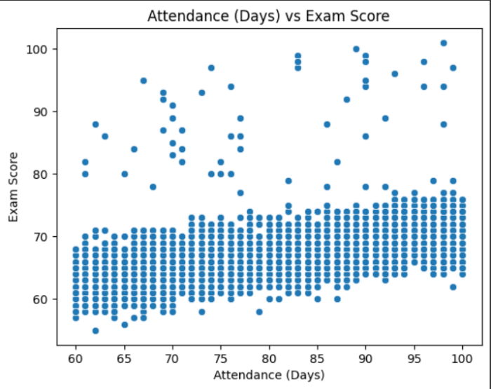

**4.3.4.1 Correlation between Exam Score and Attendance**

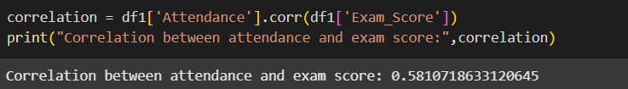

**Description:**

* Students with High attendance have the highest average exam score (78.9).
* Those with Low attendance have the lowest scores (65.3).
* The attendance analysis reveals a strong positive correlation between class attendance and exam scores.Students with higher attendance consistently perform better in exams.
* This emphasizes the critical role that consistent classroom engagement plays in academic success.Improving attendance rates could directly enhance overall student performance.

**4.3.5 Parental Education Level Analysis**

**4.3.5.1 Average Score by Parental Education Level code for 4.3.5.1 Average Score by Parental Education**

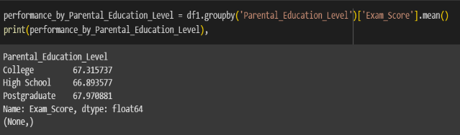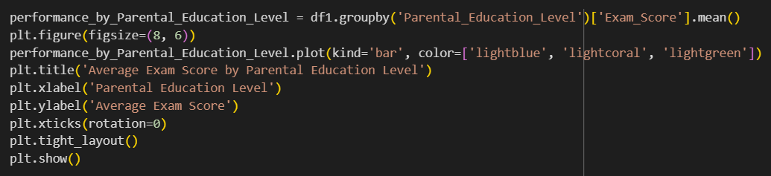 **( bar graph) Level**

**4.3.5.1 Bar chart**

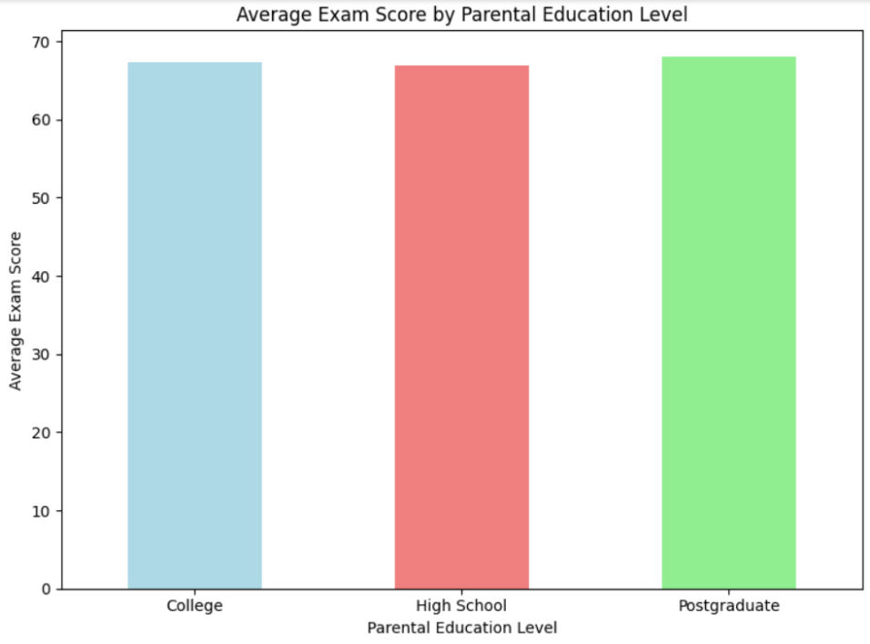

**Description:**

* The analysis shows that students whose parents have a postgraduate education perform the best, followed by those with college-educated parents.
* Students with parents who completed only high school have the lowest average scores.
* This indicates that parental education has a positive impact on student performance, likely due to better academic support, higher expectations, and a learning-friendly environment at home.

**4.3.6 Internet Access Analysis**

**4.3.6.1 Distribution of Internet Access code for 4.3.6.2 Average Exam Score of Internet Access**

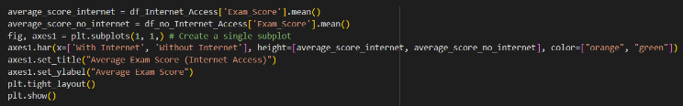 **(bar graph) (bar graph)**

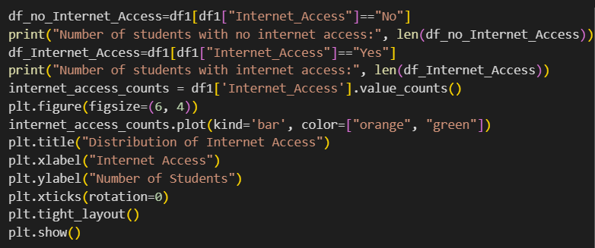

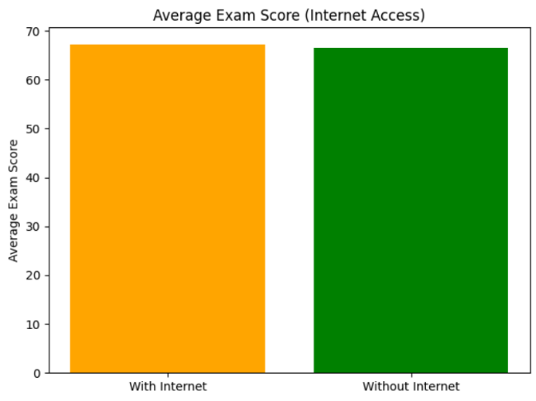 **4.3.6.1 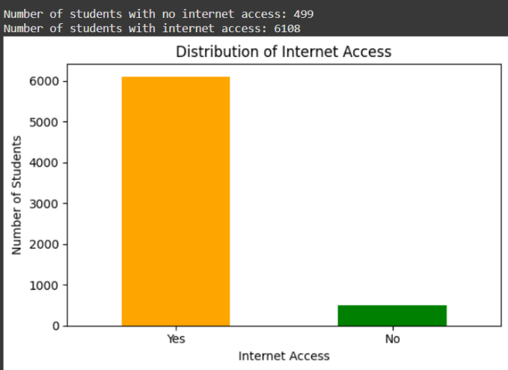Bar graph 4.3.6.2 Bar graph**

**Description :**

* Most students (6108) have internet access (orange bar).
* A much smaller group (499) does not have access (green bar).
* Most students (around 92%) have internet access.
* Students with internet access tend to perform slightly better in exams on average.
* Internet access may provide an advantage, possibly due to easier access to study materials, online resources, and learning platforms

**4.3.8 Motivation Level Analysis**

**4.3.8.1 Average Exam Score by Motivation Level**

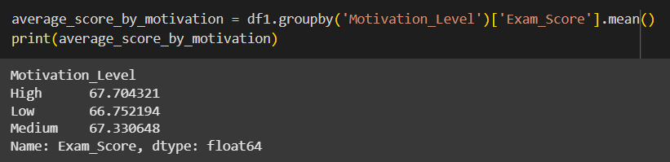

**4.3.8.1 Average Exam Score by Motivation Level code for (bar graph)**

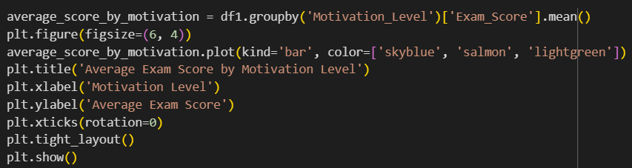

**4.3.8.1 Bar graph**

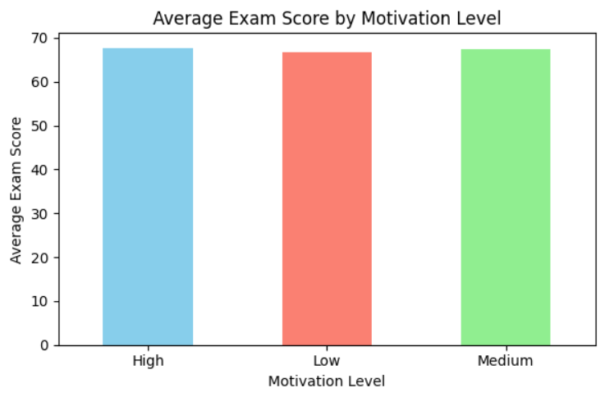

**Description:**

* Students with high motivation scored the highest average exam score (75.27).
* Students with medium motivation scored moderately (65.61).
* Those with low motivation scored the lowest (55.27).
* There is a strong positive link between motivation and student performance.
* Highly motivated students perform significantly better than those with low motivation.
* Motivation clearly drives students to put more effort into studies, resulting in better scores.

**4.3.9 Family Income Analysis**

**4.3.9.1 Averge Exam Score by Family Income code 4.3.9.1 Averge Exam Score by Family Income**

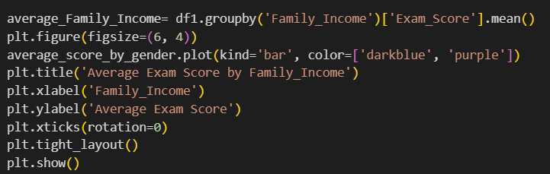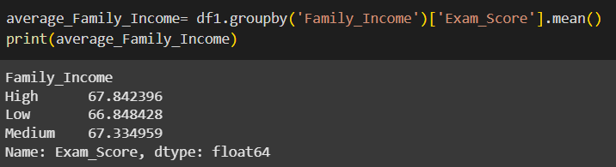 **for (bar chart)**

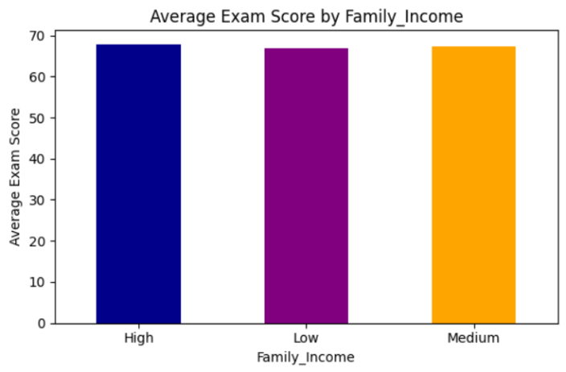 **4.3.9.1 Bar chart**

**Description:**

* The difference between categories is small—less than 1 point between High and Low.
* Minor correlation: Family income might have a slight influence on exam performance, but it's not dramatic.
* Educational equity The small gap suggests that students from different income backgrounds perform similarly
* It means that the high family income students perform slightly better among other because they get more benefits like ,personal tutor,tutorials,quality teachers etc
* But where has low income people would may get quality teacher but mostly they has average only
* So,this could be the main reasons for the changes in performance

**4.3.10 Sleep Hours Anaylsis**

**4.3.10.1 correlation between Exam Score and**

**Sleep Hours code for (scatter plot)**

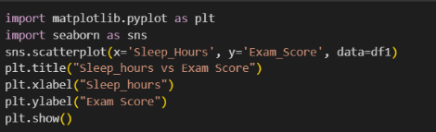

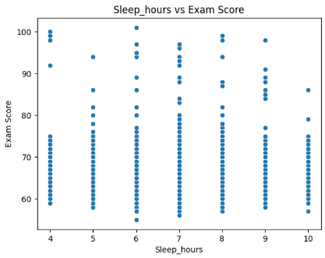 **4.3.10.1 Scatter plot**

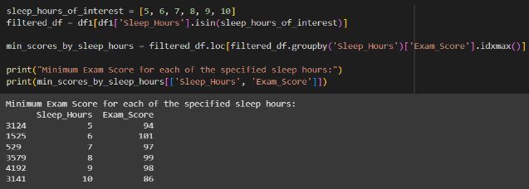

**4.3.10.2 Maximum Exam Score by Sleep Hours 4.3.10.2 Maximum Exam Score by Sleep Hours**

**code for (scatter plot)**

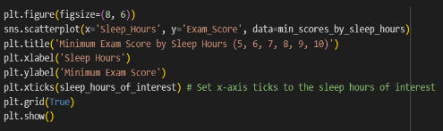

**4.3.10.2 Scatter plot**

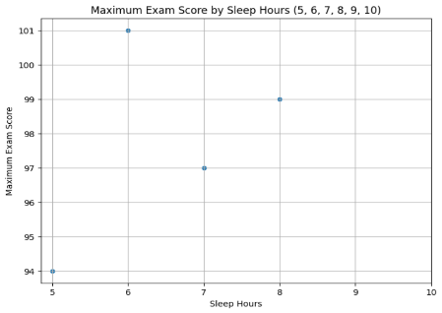**4.3.10.3 Maximum Exam Score by Sleep Hours 4.3.10.3 Maximum Exam Score by Sleep Hours**

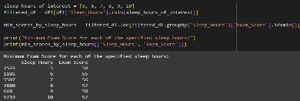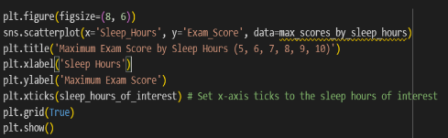**code for (scatter plot)**

**4.3.10.3 Scatter plot**

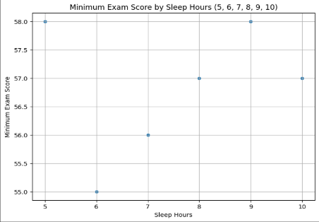

** 4.3.10.4 Correlatation Between Exam Score and Sleep Hours**

**Description:**

* Students who sleep 8 or more hours (High sleep) have the highest average score (74.23).
* Students with 5–7 hours (Medium sleep) perform moderately (66.29).
* Students with very little sleep (0–4 hours) score the lowest (56.91).
* But we can see in the average chart in that the student who got highest marks has sleep hours has 6 also one who got lowest.
* Here we can consider the sleep hours does matter but also not because the students who has more productive and know how to utilize the time has got highest marks at the same time one who not utilizing the time properly has got lowest marks

**4.3.11 Teacher Anaylsis**

**4.3.11.1 Averge Exam Score by Teacher Quality code 4.3.11.1 Averge Exam Score by Teacher**

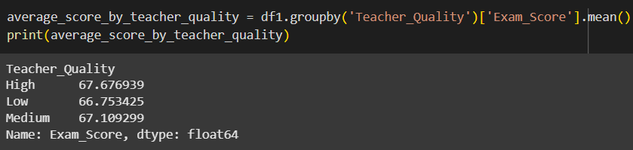**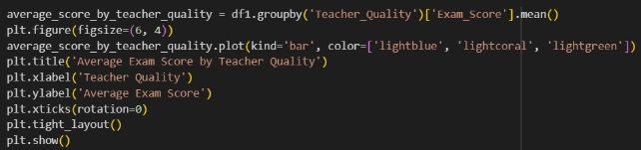 code for (bar graph)**

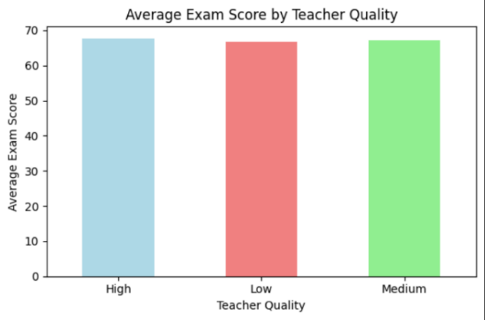 **4.3.11.1 bar graph**

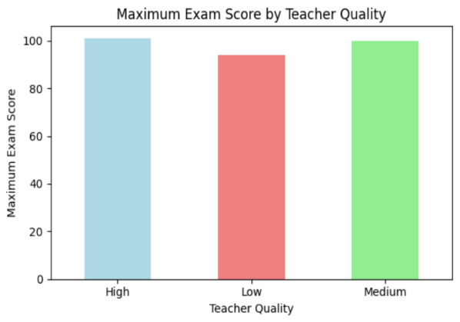 **4.3.11.2 Bar graph**

**4.3.11.2 Maximum Exam Score by Teacher**

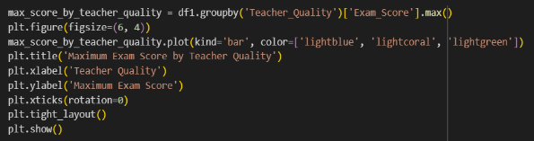 **Quality Code for (bar graph)**

**Description:**

* There is a positive impact of teacher quality on student performance, even though the score difference is small.
* Better teachers lead to slightly better academic outcomes, likely due to clearer explanations, effective teaching methods, and student engagement.Improving teaching quality can gradually enhance overall student performance.

**4.5 SUMMARY OF PROJECT**

**Key Findings:**

* **Gender:** There is a slight difference in average exam scores between genders, with females having a slightly higher average. However, a female student achieved the highest individual exam score (101).
* **School Type:** Both private and public schools show very similar average exam scores. The distribution of students by distance from home shows that a larger proportion of students in public schools live closer to home compared to private schools.
* **Learning Disabilities:** Students without learning disabilities tend to have a slightly higher average exam score compared to those with learning disabilities.
* **Extracurricular Activities:** Participation in extracurricular activities appears to have a minimal impact on average exam scores, with a very small difference observed between students who participate and those who do not.
* **Attendance:** There is a moderate positive correlation between attendance and exam scores, suggesting that higher attendance is generally associated with higher exam scores.
* **Parental Education Level:** Students whose parents have a postgraduate education level tend to have slightly higher average exam scores compared to those with college or high school educated parents.
* **Internet Access:** Students with internet access have a slightly higher average exam score than those without internet access. The vast majority of students in this dataset have internet access.
* **Family Income:** Students from families with higher income levels have a slightly higher average exam score compared to those from low- or medium-income families.
* **Motivation Level:** Students with high motivation levels have the highest average exam scores, followed by those with medium and low motivation levels.
* **Sleep Hours:** There is a negligible correlation between sleep hours and average exam score. However, the analysis of maximum and minimum scores for specific sleep hours shows variability, indicating that while average scores may not be strongly affected, individual performance can vary regardless of sleep hours within the observed range.

**4.6 RECOMMENDATIONS TO IMPROVE STUDENT PERFORMANCE**

* **Address Learning Disabilities:** Provide targeted support and resources for students with learning disabilities to help them bridge the achievement gap.
* **Promote Attendance:** Implement strategies to encourage regular attendance, as it shows a positive correlation with exam scores. This could include addressing reasons for absenteeism and offering incentives for good attendance.
* **Support Parental Involvement:** While the analysis of parental education level shows some influence, further investigation into how parental involvement (beyond just education level) impacts scores could be beneficial. Programs to encourage parental engagement and provide resources for supporting student learning at home could be explored.
* **Ensure Internet Access:** While most students have internet access, ensure that all students have equitable access to online resources and learning opportunities, especially in today's increasingly digital learning environment.
* **Foster Motivation:** Develop programs and strategies to boost student motivation levels, as higher motivation is associated with better exam performance. This could involve personalized learning approaches, goal setting, and celebrating achievements.
* **Investigate Score Fluctuations:** Analyse the factors contributing to significant improvements or decreases in scores to identify best practices for supporting student growth and addressing potential challenges.
* **Consider Teacher Quality:** While the average scores across teacher quality levels are similar, further investigation into the characteristics of "High" quality teachers and how to replicate those factors across all teachers could be beneficial. Professional development programs focused on effective teaching strategies could be valuable.